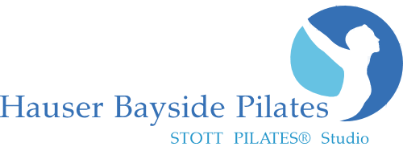
www.HauserPilates.com
* CLASS Schedule

Monday
10:00am Cardio Jumpboard Reformer 1819 West Ave#4, Miami Beach, FL 33139 (917) 656-7977
6:00pm Reformer Class

Tuesday
* All Classes Require Online Pre sign-up! www.HauserPilates.com
W

7:00am Early Bird Reformer
9:00am Barre Class
10:00am Reformer
5:30pm Pilates Mat
6:30pm Tower Reformer Class

Wednesday
10:00am Reformer
New Client Special
2 Classes for $48!

Good for all Classes
(2 week expiration)
s for $45!

Good for all Classes
(2 week expiration)
Thursday
7:00am Early Bird Reformer
9:00am Tower Reformer Class
10:00am Reformer
5:30pm Mat Pilates
6:30pm Reformer Class

Friday
10:00am Reformer Class

Saturday Sunday
9:00am Reformer Class 9:00am Sunday Reformer Energize
10:00am Reformer Class 10:00am Sunday Reformer Energize

**** Always check online for the current schedule as classes may change. Class instructors are subject to change based on availability.

Class Sign-up, and Private Appointments: www.HauserPilates.com
Call: (917) 656-7977 Email: hauserpilates@yahoo.com
Studio Hours: 8:00am – 8:00pm M-F and Sat. & Sun. morning. Other hours available at the discretion of Owner at $130 hr.
Classes accommodate 6-8 people. All sessions are 55min long. Must pre sign-up online for classes. 24 hour cancellation policy.
All purchases are Final Sale. We accept MC, Visa, Debit card, Discover, Cash or Check
All Class Packages& Private Packages are valid for 3-months from date of purchase. Maximum 1 class per day.

Barre Classes Single Class: $42 5-pack: $180 ($36 ea.) 10-pack: $335 ($33.50 ea.)
Mat Classes Single Class: $36.50 5-pack: $155 ($31 ea.) 10-pack: $284 ($28.40 ea.)
Reformer Classes Single Class: $42 5-pack: $180 ($36 ea.) 10-pack: $335 ($33.50 ea.)
Reformer/Mat/Barre Classes 5-pack: $195 ($39 ea.) 10-pack: $362 ($36.20 ea.)
---------------------------------------------------------------------------------------------------------------------------------------------------------------
Private Sessions Single: $125 5-pack: $567.00 ($113ea.) 10-pack: $1025.00 ($102.50 ea.)
Duo/Semi-Private (2 person) Single: $165 ($82 pp) 5-pack: $386 ($77.20 pp) 10-pack: $720 ($72 per session/pp)
Trio/Semi-Private (3 person) Single: $201 ($67 pp) 5-pack: $310 ($62 per session/pp)

