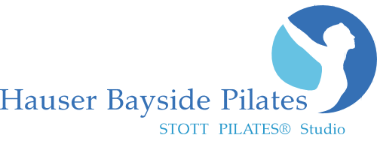
www.HauserPilates.com
* CLASS Schedule

Monday
10:00am Reformer 1860 West Ave, Miami Beach, FL 33139 (917) 656-7977
6:00pm Reformer
* All Classes Require Online Pre sign-up! www.HauserPilates.com
W

Tuesday
7:00am Early Bird Reformer
9:00am Barre Class
10:00am Reformer
5:30pm Pilates Mat
6:30pm Reformer

Wednesday
10:00am Reformer
6:00pm Reformer
New Client Special
2 Classes for $45!

Good for all Classes
(2 week expiration)
s for $45!

Good for all Classes
(2 week expiration)

Thursday
7:00am Early Bird Reformer
9:00am Barre Class
10:00am Reformer
5:30pm Mat Pilates
6:30pm Reformer

Friday
10:00am Reformer
6:00pm TGIF Pilates and Prosecco Reformer

Saturday Sunday
9:00am Reformer 9:00am Sunday Reformer Energize
10:00am Reformer

Class Sign-up, Private Appointments & Massage Appointments: www.HauserPilates.com
Call: (917) 656-7977 Email: hauserpilates@yahoo.com
Studio Hours: 8:00am – 8:00pm M-F and Sat. & Sun. morning. Other hours available at the discretion of Owner at $95 hr.
Classes accommodate 6-8 people. All sessions are 55min long. Must pre sign-up online for classes. 24 hour cancellation policy.
All purchases are Final Sale. We accept MC, Visa, Debit card, Discover, Cash or Check
All Class Packages& Private Packages are valid for 3-months from date of purchase. Maximum 1 class per day.

Barre Classes Single Class: $35 5-pack: $175 ($35 ea.) 10-pack: $300 ($30 ea.)
Mat Classes Single Class: $35 5-pack: $150 ($30 ea.) 10-pack: $250 ($25 ea.)
Reformer Classes Single Class: $40 5-pack: $175 ($35 ea.) 10-pack: $325 ($32.50 ea.)
Reformer/Mat/Barre Classes 5-pack: $190 ($38 ea.) 10-pack: $350 ($35 ea.)
---------------------------------------------------------------------------------------------------------------------------------------------------------------
Private Sessions Single: $110 5-pack: $500 ($100 ea.) 10-pack: $950 ($95 ea.)
Duo/Semi-Private (2 person) Single: $150 ($75 pp) 5-pack: $350 ($70 per session/pp) 10-pack: $1300 ($65 per session/pp)
Trio/Semi-Private (3 person) Single: $180 ($60 pp) 5-pack: $290 ($58 per session/pp)

