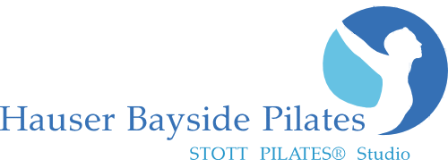
www.HauserPilates.com
* CLASS Schedule

Monday
10:00am Reformer 1860 West Ave, Miami Beach, FL 33139 (917) 656-7977
6:00pm Reformer
7:00pm Barre/Core/Stretch
* All Classes Require Online Pre sign-up! www.HauserPilates.com
W

Tuesday
9:00am Reformer
10:00am Cardio Jumpboard Reformer
5:30pm Pilates Mat
6:30pm Reformer

Wednesday
9:00am Cardio Jumpboard Reformer
10:00am Reformer
10:00am Barre
New Client Special
2 Classes for $45!

Good for all Classes
(2 week expiration)
s for $45!

Good for all Classes
(2 week expiration)
6:00pm Reformer
7:00pm Barre/Core/Stretch

Thursday
9:00am Reformer
10:00am Reformer
5:30pm Mat Pilates
6:30pm Reformer

Friday
9:00am Cardio Jumpboard Reformer
10:00am Reformer
10:00am Barre

Saturday Sunday
9:00am Reformer 9:00am Sunday Reformer Energize
10:00am Barre 10:00am Sunday Jumpboard Reformer & Stretch
10:00am Reformer

Class Sign-up, Private Appointments & Massage Appointments: www.HauserPilates.com
Call: (917) 656-7977 Email: hauserpilates@yahoo.com
Studio Hours: 7:00am – 8:00pm M-F and Sat. & Sun. morning. Other hours available at the discretion of Owner at $95 hr.
Classes accommodate 6 people. All sessions are 55min long. Must pre sign-up online for classes. 24 hour cancellation policy.
All purchases are Final Sale. We accept MC, Visa, Debit card, Discover, Cash or Check
All Class Packages& Private Packages are valid for 3-months from date of purchase. Maximum 1 class per day.

Barre Classes Single Class: $28 5-pack: $125 ($25 ea.) 10-pack: $220 ($22 ea.)
Mat Classes Single Class: $35 5-pack: $150 ($30 ea.) 10-pack: $250 ($25 ea.)
Reformer Classes Single Class: $40 5-pack: $175 ($35 ea.) 10-pack: $300 ($30 ea.)
Reformer/Mat/Barre Classes 5-pack: $190 ($38 ea.) 10-pack: $325 ($32.50 ea.)
---------------------------------------------------------------------------------------------------------------------------------------------------------------
Private Sessions Single: $95 5-pack: $450 ($90 ea.) 10-pack: $850 ($85 ea.)
Duo/Semi-Private (2 person) Single: $130 ($65 pp) 5-pack: $625 ($62.50 pp) 10-pack: $1200 ($60 pp)
Trio/Semi-Private (3 person) Single: $165 ($55 pp)

